Guerrero, Cristobal
CIS-17A 42380
Mark Lehr
Final Project

Table of Contents
Introduction: 3
Summary: 3
Statistics: 4
Classes: 4
Auto: 4
Manual: 5
Validate: 6
Information: 7

Introduction:
I have always admired simulations and I wanted to put together a program that would be able to run one. The simulation that I wanted to do was that of a typical soda machine. I wanted to be more creative with this if there was a graphic package to use though I had none available to me at the time. In essence the project typically runs through what a soda machine operation would consist of. Now the problem was how to manage this machine and how the user could interact with it as well. My idea was taken from a CIS-5 problem which did the same, though I wanted to expand on it and have the user act as the owner of the machine.
The user could either test if the machine was running smoothly and be able to program the machine as well. This was going to be done by having the user input themselves as entering auto to test the machine or a manual run that would have them fill the machine electronically. This could be and would be beneficial to companies to get an electronic feed to refill machines as well as to electronically test if input was being taken correctly. The user will begin by either choosing to use fill or auto and depending on their choice it will transfer them to different menus.
If the user chooses to fill the machine they will first be asked to input the names of the soft drinks or whatever they really want to fill the machine with. This will be done with a general cout/cin and will be placed in the C++ class file for storage. The user then is asked to input the prices for each item and then ask them to test the machine so that everything is running accordingly. The user is then prompted if they would like another soda and if not the program will end.
If the user chooses to use the auto run option for the machine because it is pre-filled then the user will be given the choice of what drink to have and with a certain price. There is an error proof part of the code that runs to check if the user is putting in the right amount of currency. The reason for this is that in the real world there are no bills that are exactly $1.25 the user must place a dollar in the machine and then a quarter to reach that amount instead. When all is done the user is then asked if they would like another soda if they do it will run starting from the auto function and then go through the same process. If the user does not want to continue the program ends and outputs for them to enjoy their soda beverage.

Summary:
This program should be equivalent to approximately 1000 lines of code more or less. Which will be needed to be able to present the items learned in class. Now the problem is with the extension of the code since it is such a simplistic program that object programing is not needed for it. Though utilizing this will make it more efficient and will reduce any issues if done with normal programing methods.
Now as a run through for the program it basically takes in a users input and then places it into an array. Then the pricing for the sodas is placed into the array that holds the prices. I did not utilize a 2-dimensional array though it could have been implemented by having the index for the soda the same as the index for the price. As you will see with the walk-through/brief tutorial it will be easy to see how the program works.

Statistics:
This program will be using multiple classes and will have a class for each procedure such as the automatic fill of the machine as well as the filling of the machine itself. Another class will be that of checking for currency as well as other input. The classes are as follows:
Classes:
Auto:
class Auto {

public:
//constructor
Auto();
//Destructor
virtual ~Auto();
//set functions
void setsize(int);
void setindex(int);
void setsoda();
void setmoney();
//fill functions
double *moneyfilled();
string *machinefilled();
//get functions
double getmoney();
int getsize();
string getsoda();
//Print fucntions
void printarray();
void vendprintcost();
private:
int index;
int autosize;
string *automachine;
double *autocost;
};

Manual:
class Manual {
public:
Manual();
Manual(const Manual& orig);
virtual ~Manual();
void setsize(int);
void setindex(int);
void setsoda();
void setmoney();
void setarraysize();
//fill functions
double *manualmoney();
string *manualsoda();
//get functions
double getmoney();
string getsoda();
int getsize();
//Print fucntions
void printarray(int);
void vendprintcost();
private:
int index;
int manualsize;
string *manualmachine;
double *manualcost;
};

As it can be seen the manual and auto class are very similar. The only exception is that one has an auto fill and the other is manually done by the user. One class could have been efficient though making the coding lines as well as separation of confusion was the main concern. Even so one class could have been inherited by another but I chose not to do this due to the confusion factor of having an auto class mixed with the manual class.

Validate:
class Validate {
public:
Validate();
Validate(const Validate& orig);
double Moneyverify(double);
string Moneyquestion(double);
void Automanualset(string);
string Automanual(string);
int Sodachoice(string);
virtual ~Validate();
private:
string decision;
string verify;
string value;
};

The validation class takes in multiple items and validates them. For instance the moneyverify object compares a string and then returns a double for the currency that was placed in the machine.

Information:
class Information {
private:
string Intro;
public:
Information();
void printinformation();
};
The information class is very simplistic and only displays the instructions for the program so that the user gets a feel of what they are supposed to do in the beginning of the program.

Walk-through/Sample:
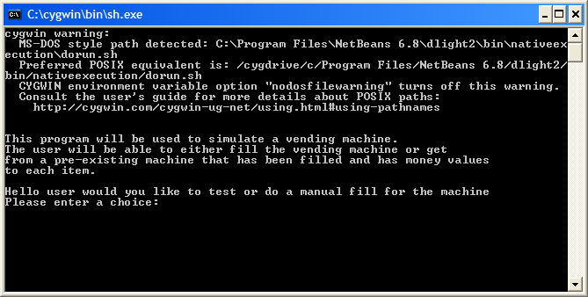
Here in the beginning of the program the introduction is given and then it prompts the user for an input if they want to fill or test the machine. Lets do an auto fill so that we can see how the machine works.
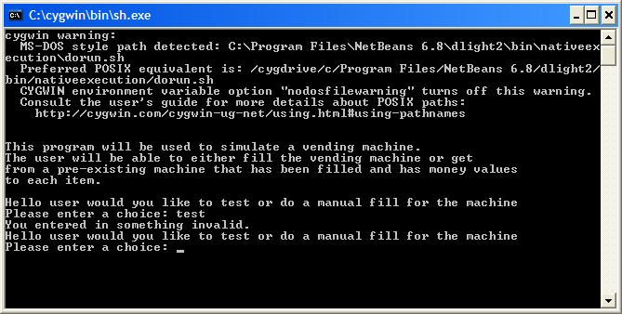
Notice that I put in the word test which is an invalid choice and the user is once again asked if they want to do a choice or not. Now lets put in “auto”.
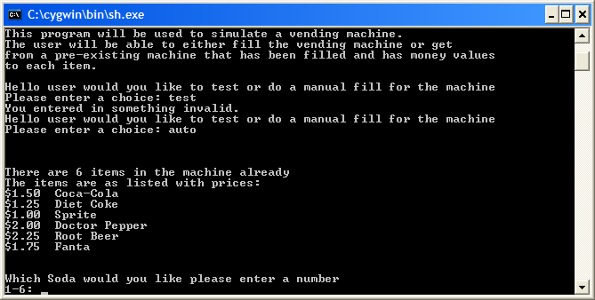
See here after putting in the string auto the machine that was pre-filled is displayed on the screen and the user is then prompted again for the soda of their choosing. The user must put in a valid integer in order for the soda to be chosen.
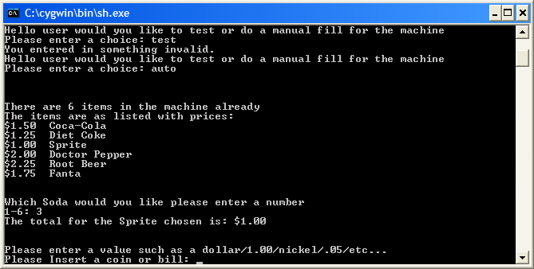
The user is now asked to place in currency. This is where the validation comes in where it checks if it is an actual bill or coin by either putting it in decimal value or typing out the coin or bill.
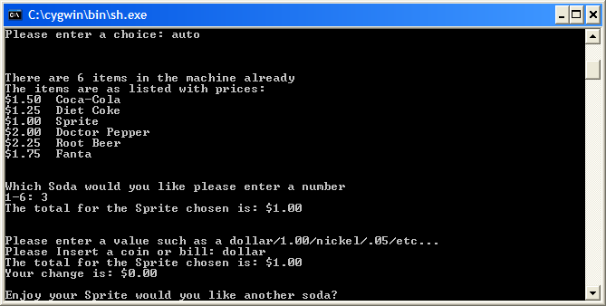
Since we choose sprite which was only a $1.00 we could have typed 1.00 or the word dollar. If there was an incorrect value placed in the machine then it would have spat back an error.
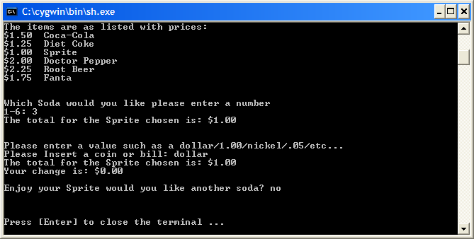
The user was asked if they wanted another soda if they had typed in yes it would have gone through the program again and gone through the same procedure.

Extras:
now if I wanted to expand on this more I could have done a full machine interface with money in the actual machine as well as an amount of sodas in the machine as well. That way when prompted over again if they wanted another soda it would be invalid if there were not anymore Dr. Pepper as an example.

Concepts:
Many concepts were utilized in this program from constructors to destructors to object oriented programing in general. Now the program could have had some inheritance though it was not necessary for such a simple program as this. If it had a better a.i. Or if was a game inheritance would be the key to the success of the program itself.

Flow Chart:
Start Program
User Decision
for Testing

User Prompt
for direction
Populate the array
for the names
and the cost

Prompt user for the
soda they want

Ask the user to
enter the currency
Call the function that
keeps track
of the user total

Checks the total

Prompt user if they
want to do it again

exit

References:
The references to this program were that of the CIS-5 class from a problem from the book. I expanded on it and continued to make it more, complex then what it should have been. Though the learning experience was fun and full filling.

